Feedback Design/Practice
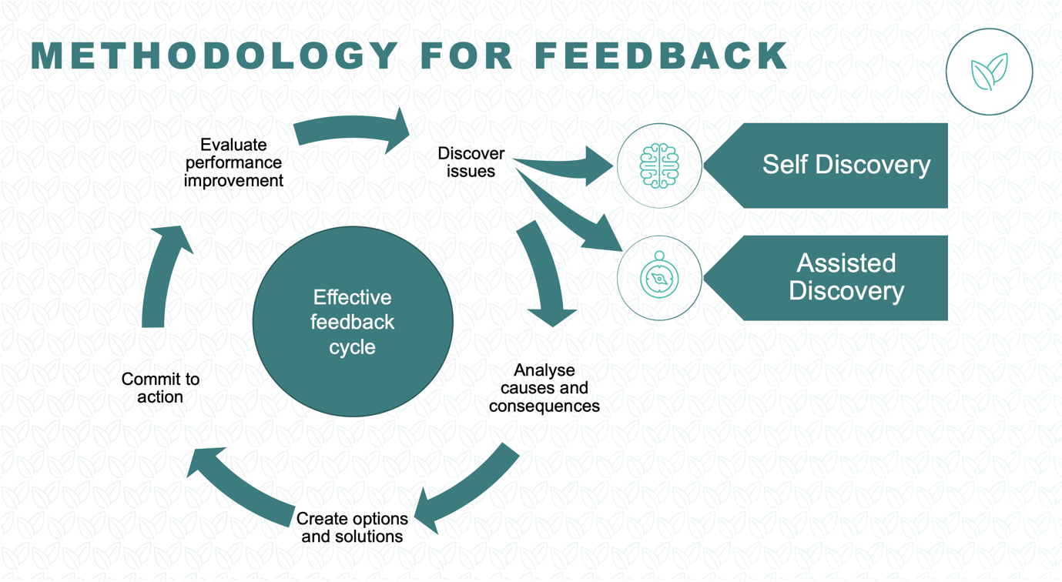
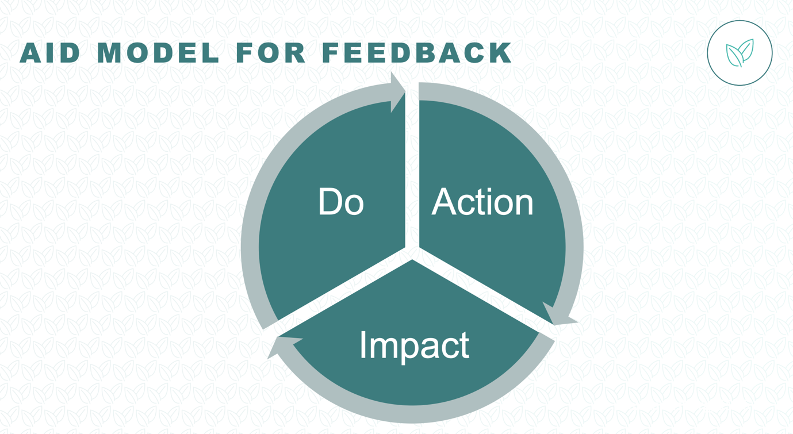

- Action - specific behaviour in a specific situation. When I saw you doing…
- Impact - On you / perceived on others. Personal / non judgemental
- The impact on me was…
- Desire for Change - What I would like to see differently is…

A: When you arrive late for meetings, I: You can miss the set up that frames the goals for the meeting, D: Could you arrive on time for future meetings?

The worst distance between two people is misunderstanding
Who would you like to feedback to?
What is it that they’re doing that is adversely affecting the success of the team?
What are the specific behaviours?
What are the causes of this behaviour?
What beliefs does the individual hold which makes this behaviour more likely?
What are the impacts of this belief/behaviour?
What new beliefs/behaviours are required to make an improvement?
How can we make these beliefs/behaviours happen together?
How can I recognise the person when I catch them doing it right?
When and how will you offer this feedback?

